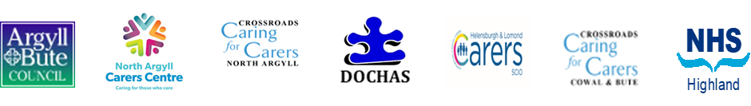
CARER’S REFERRAL FORM
About the Carer
Title
First Name
Surname
Address
Postcode
Landline
Mobile
Email address
Preferred contact method |  |  | Post Landline Mobile Email
Gender
Date of Birth
Age
Is an advocate required? |  |  | Yes No
Is an interpreter required? |  |  | Yes No
Does carer live with person they care for |  |  | Yes No
How long has the carer been providing care?
Carer’s GP/Medical Practice (if known)
Carer health - please advise of any issues/disabilities
As well as caring does the carer have other responsibilities?
Full Time work (over 16 hours) |  |  |  |  | Part Time work (less than 16 hours)
School/Further Education/Training |  |  |  |  | Family Commitments
Voluntary Work |  |  |  |  | Other (specify below
Referral type
Adult Carer Support Plan Young Carers Statement Other
Cared-for person
Name of cared-for person
Cared-for person’s age
Relationship to carer
Caring role
Referrer Details
Name
Designation/role
Contact number
Email address
Reason for referral
Support currently provided by referrer/referral organisation:
Permission to share information
Has the carer consented to this referral and the sharing of their information to other agencies? |  |  |  |  |  | Yes No
Carer’s signature:
Date:
Parent/guardian’s signature (if required):
Date:
Referrer’s signature:
Date:
Thank you for completing this referral form. Please post or email it to:
For: Cowal & Bute
Crossroads 61-63 Argyll Street, Dunoon PA23 7HG
Email: carers@crossroadscowalandbute.org.uk
Tel: 01369 707700
For: Oban, Lorn and the Isles
North Argyll Carers Centre, Albany Street, Oban PA34 4AL
Email: info@northargyllcarers.org.uk
Tel: 01631 564422
For: Helensburgh & Lomond,
Helensburgh & Lomond Carers, 17E East King Street, Helensburgh G84 7QQ
Email: admin@hlcp.helensburgh.co.uk
Tel: 01436 673444
For: Mid Argyll, Kintyre & Islay (adult carers)
Dochas Carers Centre, 50 Campbell Street, Lochgilphead PA31 8JU Email: enquiry@dochas.scot
Tel: 01546 600022
For: Mid Argyll, Kintyre & Islay (young carers)
Mid Argyll Youth Development Service (MAYDS) 50 A Union Street Lochgilphead PA31 8JS
Email: info@mayds.org.uk
Tel: 01546 603231

